Ansible tasks

Task 1



Task 2

**Cd /etc/ansible/hosts**.

At the bottom of this file, declare your node inside a group called hosts, as below.

[hosts]

IP HERE

Task 3

$ ssh-keygen -t rsa

$ ssh-agent bash

$ ssh-add ~/.ssh/id_rsa

$ ssh-copy-id vagrant@NODEIP

Ping agent ip

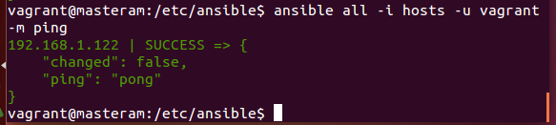

Task 4

Test this was successful by running the command from the master.

ansible all -i hosts -u vagrant -m setup

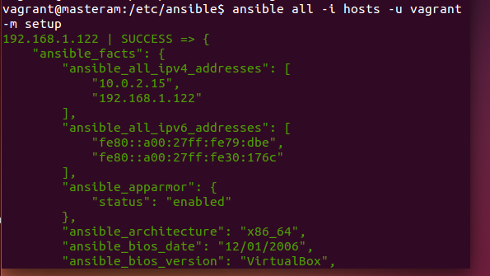

Playbooks